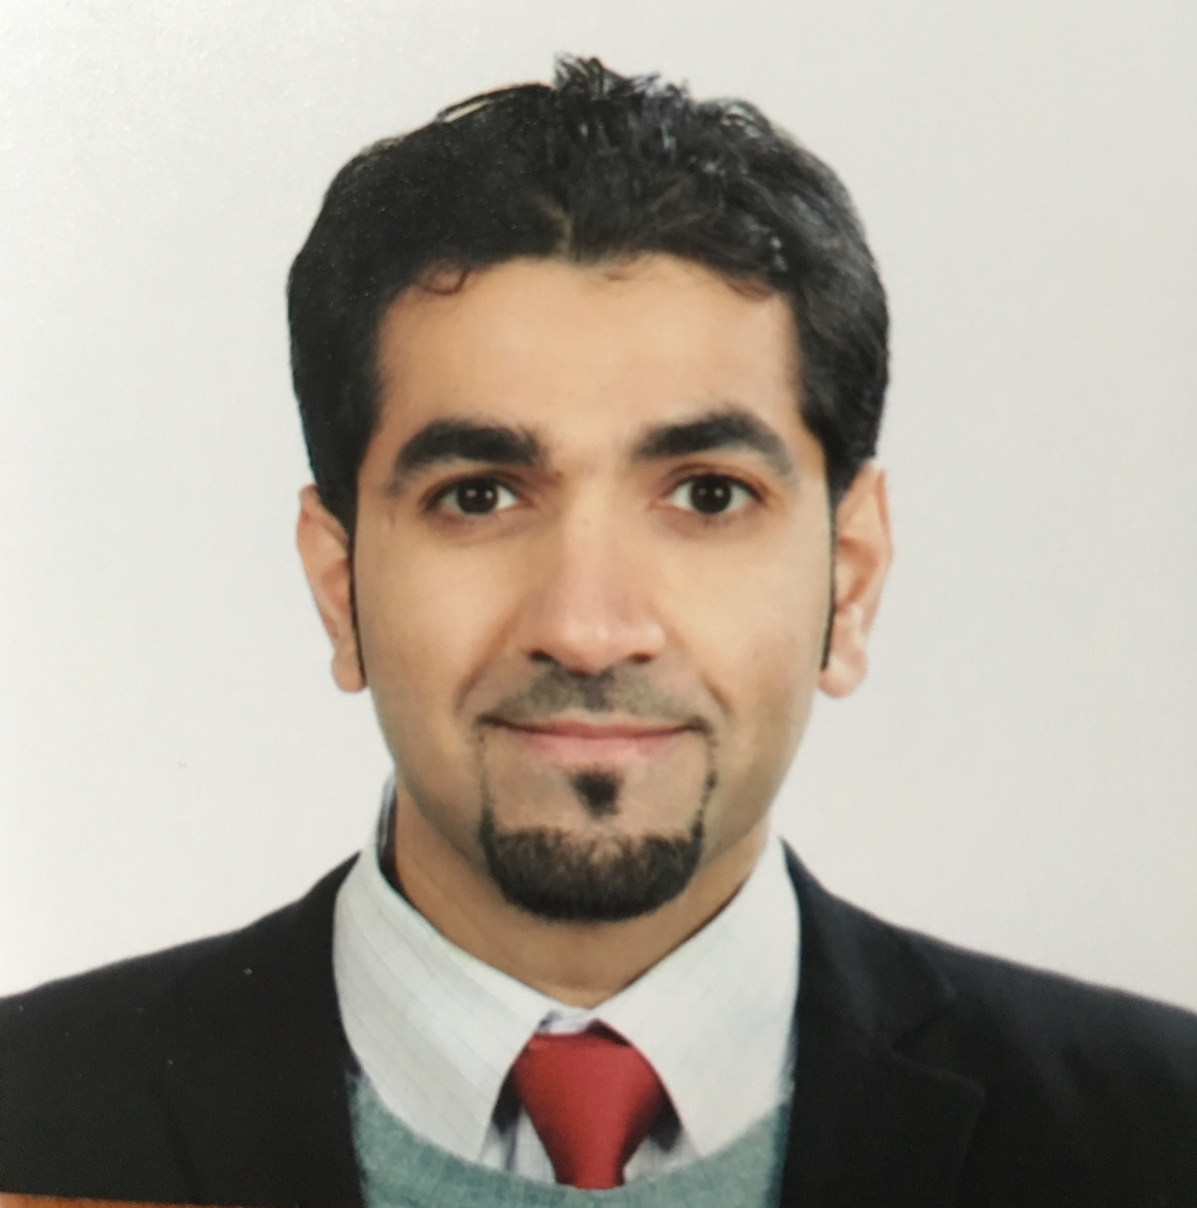
Curriculum vitae

Mahdi Hussain AL-Bandar

cONTACT informations

Name: Mahdi Hussain N. Al-Bandar.
The Address: Al-Olaya, Takhassusi St., Riyadh, Saudi Arabia.
PO Box: 10081, 31982, Saudi Arabia.
Cell Phone: +966566134466
Work Tell: +966114355555 ext. 1246
E-mail: MHB3001@Hotmail.com

personal informaitons

- Date of birth: 24/4/1983
- Marital status: Married.
- Nationality: Saudi.
- Gender: Male.

Qualification

- Representative of General Surgery Cluster in Ministry of Health, South Province
King Saud Medical City, Riyadh, Saudi Arabia. 2018-Present
- Deputy Head of General Surgery Department 2019- 04
King Saud Medical City, Riyadh, Saudi Arabia.
- Assistant Clinical Professor in Al Maarefa College 2017-Present
Al Maarefa College, Riyadh, Saudi Arabia.
Worked as Consultant General Surgery, Colorectal and Bariatric surgery
- King Saud Medical City, Riyadh, Saudi Arabia. 2016- Present
- Fellow in Minimum Invasive Surgery and Bariatric Surgery in Canada 2018
General Surgery Department, Toronto University, Ontario, Canada
- Clinical Fellow in Gastroenterology and Surgical Oncology 2015-2016
Severance Hospital, Seoul, South Korea
- Clinical Fellow in Bariatric surgery 2015-2016
Severance Hospital, Seoul, South Korea & Asian Bariatric Center, India
- Clinical Fellow in Minimum Invasive and Robotic Surgery in Colorectal
&Surgical Oncology 2014-2016
Severance hospital, Seoul, South Korea
- Worked as Assistance General Surgery Consultant 2013-2014
Kind Saud Medical City, Riyadh, Saudi Arabia.
- General Surgery Residency Program of Saudi Board 2008-2013
Saudi Commission of Health Specialties, Saudi Arabia
- General Surgery Residency program of Arab Board 2008-2013
Arab Commission of Health Specialties, Syria

Membership
- Member of International Federation for the Surgery of Obesity and Metabolic Disorders (IFSO)
- Member in Saudi Obesity Society
- Member in Saudi Colorectal Forum
- Member in Saudi Laparoscopic Society

Education and courses

- Chairman and Organizer of Basic Surgical Skill and Technique Workshop 2018/now
Kind Saud Medical City, Riyadh, Saudi Arabia.
- Chairman and Organizer of Basic Laparoscopic Surgery Workshop 2018
Kind Saud Medical City, Riyadh, Saudi Arabia.
- Instructor in Basic Operative Surgical Skills (BOSS) Course 2017-2018
Security Forces Hospital, Riyadh, Saudi Arabia.
- Chairman and Organizer in Saudi Laparoscopic Society 2018
King Saud University, Riyadh, Saudi Arabia
- Instructor in Basic Life Support (BLS) Course 2017
King Saud Medical City, Riyadh, Saudi Arabia
- IELTS exam, Score 6.5 2016
- Trained in Colorectal and Upper Gastro-entrology Oncology Surgery 2014-2016
Severance Hospital, Seoul, South Korea
- Advance Course in Da Vinci Robot System 2016
Severance Hospital, Seoul, South Korea
- Basic Course in Da Vinci Robot System in Seoul, South Korea 2014
Severance Hospital, Seoul, South Korea
- General Surgery Residency in Saudi Commission for Health Specialties 2013
Riyadh, Saudi Arabia.
- General Surgery Residency in Arab Commission for Health Specialties 2013
To set for final oral exam in Gulf region
- Advance Trauma Life Support (ATLS) 2011
National Guard Hospital, Riyadh, Saudi Arabia
- International Course of Laparoscopic Surgery for Obesity & Upper G I Tract 2010 Certified by American University in Beirut.
- Clinical Internship 2007-2008
King Saud University, Riyadh, Saudi Arabia
- Basic Operative Surgical Skills (BOSS) Course 2008
National Guard Hospital, Riyadh, Saudi Arabia
- Bachelor of Medicine, Bachelor of Surgery (MBBS) 2007
King Saud University (KSU), Faculty of Medicine, Riyadh, Saudi Arabia
- Advance Cardiac Life Support (ACLS) Course 2007
National Guard Hospital, Riyadh, Saudi Arabia
- Advance English language in Canada 2006
Canadian College, Vancouver, Canada

RESEARCH Activity

- Biomarkers That Predict The Response to Chemo-radiotherapy
in Rectal Cancer 2017
Published in Journal of Current Medical Research and Opinion

- A case of Gastric Cancer Metastasis to the Breast in a Female with
BRCA2 Germline Mutation and Literature Review 2017
Published in Acta Chirurgica Belgica

- Review article (Surgical Management of Extra-regional Lymph Node Metastasis
in Colorectal Cancer), 2016
Published in Expert Review of Anticancer Therapy

- Intraoperative Archive of Right Colonic Vascular Variability Aids Central Vascular Ligation and Redefines Gastro-colic Trunk of Henle Variants 2016
Published in Disease of Colon and Rectum Journal

- Optimum Level of Vessel Ligation in Splenic Flexure Cancer 2016
Published in Journal of Surgery

- Trans-anal Endoscopic Operation vs. Trans-anal Excision 2016
in Low Rectal Tumors
Published in Annals of Medicine and Surgery

- Impact of Chemo-radiotherapy on Systemic Failure in Low Advance
Rectal Cancer
Published in the Journal of Integrative Oncology.

- Incidence of Intra-abdominal Collections in Open vs. Laparoscopic 2016
Appendectomy
Published in International Journal of Scientific & Engineering Research.

- Trans-anal Endoscopic Operation vs. Trans-anal Endoscopic Microsurgery
in Low Rectal Tumors 2016
Submitted for publication Laparoendoscopic and Advanced Surgical Techniques

- Oncology Outcome in Robotic Colorectal Surgery Compared to 2016
Hand assisted Laparoscopic Surgery in Rectal Cancer
Submitted for publication

- Oncology Outcome in Open vs. Laparoscopic Surgery in Liver 2016
Metastasis of Colorectal Cancer
Pending for submission

- Prognostic Implication of Threatened Circumferential Resection 2015
Margin of Locally Advanced Rectal Cancer
Accepted in American Surgical Society of Colorectal Surgery (ASCRS), Boston, USA

- Review article (The current Scope of Robotic Surgery in Colorectal Cancer)
Published in Robotic and Automation Journal. 2015

- Book of (Surgical References in Treating Appendicitis) 2013
Published in Lap Lambert Academic

- A member in (The Epidemiology Of Acupuncture) 2005
Riyadh, Saudi Arabia – Original article, primary care department with Dr. M.Rakban

Clinical achievements

- Membership in Colorectal Saudi Society 2017-Present
Riyadh, Saudi Arabia
- Academic Member in General Surgery Residency Program Training 2016- Present
King Saud Medical City, Riyadh, Saudi Arabia.
- Membership of Basic Operative Surgical Skills (BOSS) Course 2016-Present
Security Forces Hospital, Riyadh, Saudi Arabia
- Member in Academic Teaching and Supervisor in Marefa College 2016-Present
Marefa College, Riyadh, Saudi Arabia.

- Academic and Clinical Teaching of Colorectal Fellows and Residents 2015-Present
Severance Hospital, Seoul, South Korea

- Clinical Teaching and Supervisor of Robotic Surgery 2015-2016
Simulator Center, Severance Hospital, Seoul, South Korea

- Topic research accepted as E- poster presentation 2016
American Surgical Society of Colorectal Surgery (ASCRS), Los Angeles, USA

- Topic research accepted as E- poster presentation 2015
American Surgical Society of Colorectal Surgery (ASCRS), Boston, USA

- Contributed in Robotic Live Surgery Workshop 2014
Severance Hospital, South Korea

- Being a Participate in Riyadh Surgical Club Meeting 2013
Held at Four Seasons Hotel, Al-Mamlakah Tower, Riyadh, Saudi Arabia

- Certified from The CanMEDs Workshop 2013
Conducted by the Royal of Physician and Surgeons of Canada in Collaboration with
Saudi Commission For Health Specialties, Riyadh, Saudi Arabia

- Joined Bariatric Surgery Technique Update Workshop 2011
Conducted in King Saud Medical City, Riyadh, S.A

- Contributed in General Surgery Hands-On Training Workshop 2010
Held at animal Lab in King Faisal Specialist Hospital & Research Center, Riyadh, S.A

- Being a Participant in Saudi Colorectal Surgery Forum 2010
Held at Four Seasons Hotel, Al-Mamlakah Tower, Riyadh, S.A

- Being a Participant in Basic Operative Surgical Skills (BOSS) Course 2008
Conducted in Security Forces Hospital, Riyadh, S.A

related experience
- Participating in Art Show in High School.
- Practicing Marathon and Long Distance Racing.
- Good at Writing and Making design.
Other Habits: Swimming, Fitness and Computer Skills.

referrences

- Professor Nam Kyu Kim
Professor & Chairman of the Department of Surgery, Yonsei University College of Medicine,
Director of Surgery, Yonsei University Health System
Email: namkyuk@yuhs.ac
Address: 50 Yonsei-ro Seodaemun-gu, Seoul 120-752, Korea
Office: +82-2-2228-2117 Fax +82-2-313-8289

- Professor Sung Hoon Noh
Professor & Chairman of Upper Gastroenterology Surgery, Yonsei University College of Medicine,
Director of Cancer Center, Yonsei University Health System
Email: sunghoonn@yuhs.ac
Office: +82-222282117

- Dr.Haitham AlFalah
Chief Executive of King Saud medical City, Riyadh, SA
Head of Bariatric & Metabolic Surgery
Consultant General and Bariatric Surgery
Office: 0114355555, ext. 1243

- Dr. Khalid Al Wahabi
Consultant of General Surgery and Head of Department of General Surgery
Director of King Saud Medical City, Riyadh, Saudi Arabia
Chairman of General Surgery Residency Program
Email: drkhdwahhabi@gmail.com
Office: 0114355555 ext. 1243

